University of Florida College of Medicine Department of Emergency Medicine
Fourth-Year Emergency Medicine Clerkship Syllabus

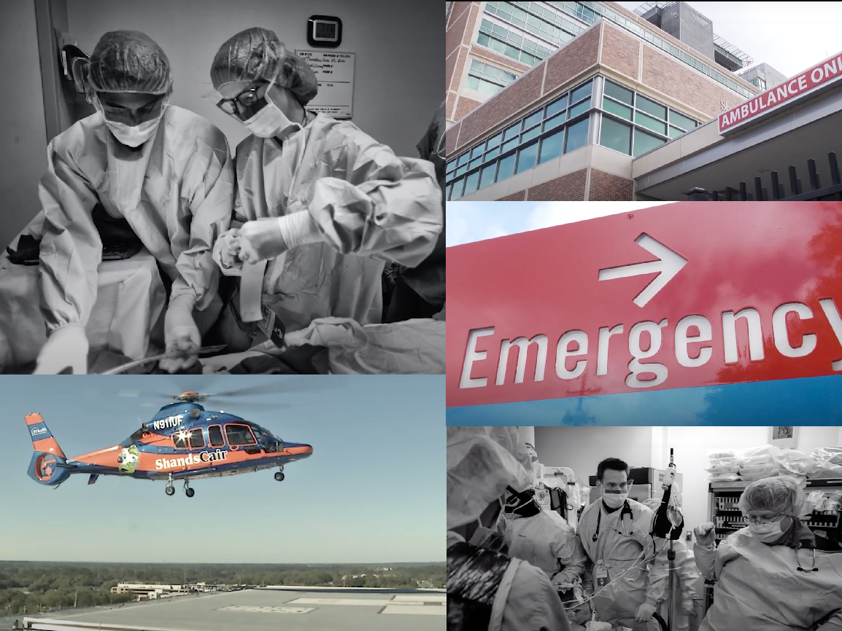

Table of Contents

Welcome Page 3
Organization and Locations Page 5
Competencies, Goals, & Objectives Page 6
Policies and Procedures Page 10
EM Clerkship Experience Page 12
Roles and Responsibilities Page 15
Student and Course Evaluation Page 16
Resources Page 17

Welcome

Welcome to the Department of Emergency Medicine and the Emergency Medicine Clerkship!

Our goal is to provide you with the skill set to needed to care for the undifferentiated emergency patient. We are dedicated to your education, and we want you to complete this clerkship with the confidence to be able to identify acutely ill patients and have the tools to start an initial evaluation and management plan.

When you walk through the doors of our department you will see a diverse mix of patients with a broad scope of acuity and presentations. You will perform an initial evaluation and follow them throughout their work-up, re-evaluating their progress until admission or discharge. There will also be several opportunities to get involved in resuscitations of critically ill medical and trauma patients and to assist with life-saving procedures.

The Emergency Medicine Clerkship consists of experiences in direct patient care of acutely ill patients, bedside teaching and ad hoc didactics on shift, weekly resident educational conference, and dedicated student review sessions in the simulation center where you will have the opportunity to practice your skills caring for critically ill medical, pediatric, and trauma patients. You will also have opportunities to perform procedures and participate in activities to pull back the curtain on critical processes that keep a busy ED running. We strive to provide every student with a safe and interactive experience ideally suited for learning. Our outstanding faculty, residents, and nurses aim to deliver excellent teaching as well as student-centered feedback for your personal growth as a physician.

As emergency medicine is a team sport, we hope you will jump right in, work hard, and display an eagerness to learn as well as help patients and colleagues. You and your future patients will benefit from this experience.

Best regards,

Meredith Thompson, M.D.
Clerkship Director

Mike Marchick, M.D.
Co-Clerkship Director

Brygitt Pfaff
Interim Clerkship Coordinator
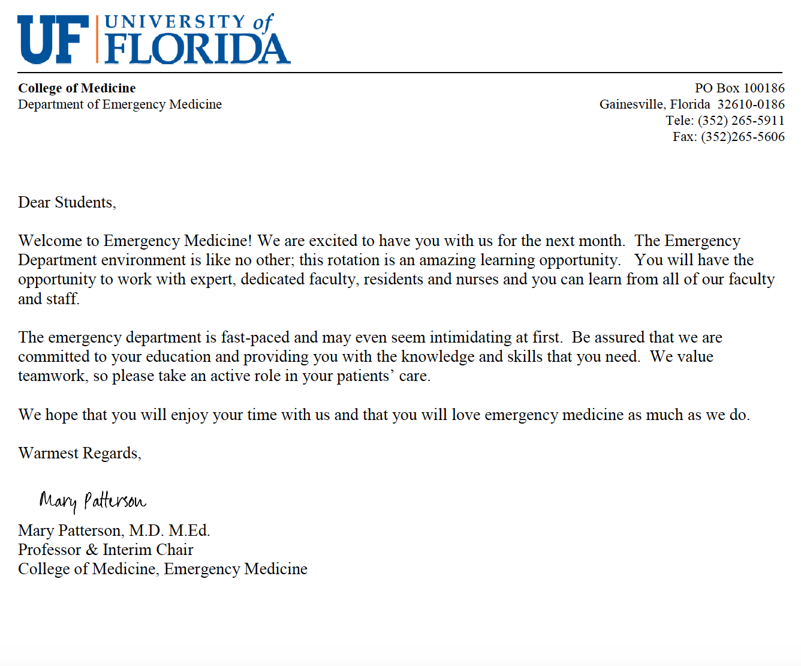

Emergency Medicine Clerkship Organization & Locations

Administration

Interim Department Chair:
Mary Patterson, M.D., M. Ed. m.patterson@ufl.edu

Emergency Medicine Medical Directors
Brandon Allen, M.D. (Adult ED) brandonrallen@ufl.edu
Carolyn Holland, M.D., M. Ed (Pediatric ED) ckhollandmd@ufl.edu

Clerkship Directors:
Meredith Thompson, M.D. |  | monin@ufl.edu
Michael Marchick, M.D. |  | marchick@ufl.edu

Emergency Medicine Clerkship Coordinator:
Brygitt Pfaff (352) 265-5911 brygitt.pfaff@ufl.edu

Vice Chair of Education
Matthew Ryan, M.D., Ph.D mfryan@ufl.edu

Emergency Medicine Residency Leadership:

Lars Beattie, M.S., M.D. | Program Director
Henry Young, M.D. | Associate Program Director
Caroline Srihari, M.D. | Assistant Program Director
Nicholas Maldonado, M.D. | Assistant Program Director
UFHealth Gainesville Emergency Department Locations

Adult Emergency Department
1515 SW Archer Road, Gainesville, FL 32608
(352) 733-0800

Pediatric Emergency Department
1600 SW Archer Road, Gainesville, FL 32608
(352) 265-5437

Emergency Department Offices
1329 SW 16th Street Suite 5270
Gainesville, FL 32610
(352) 265-5911

COMPETENCIES, GOALS & OBJECTIVES
The Department’s expectations of your performance are aligned with the College of Medicine’s competency-based curriculum. You will experience, be taught, and evaluated specifically on your performance of the following competencies, goals, and objectives:

Competencies

Professionalism (P)
  - Practice-based learning (PBL)
  - Patient care (PC)
  - Interpersonal and communication (IC)
  - Medical knowledge (MK)
  - System based practice (SBP)

Goals & Objectives

GOAL 1: Evaluate and manage patients in the Emergency Department.
Objectives:
- Independently obtain and record a patient’s history in a logical, organized, and thorough manner, taking into consideration the developmental stage of the patient. (PC)
- Refine physical examination skills by independently performing and recording a physical examination in a logical, organized, and thorough manner including advanced physical examination maneuvers. (PC)
- Understand and be able to communicate the reason for the patient’s presentation to the emergency department and learn admission criteria for common illnesses. (PC, IC, MK)
- Recognize patients requiring emergent attention by a supervising physician. (PC, IC)
- Recognize and stabilize patients with life-threatening conditions. (PC)
- Initiate patient orders, understand the rationale for each order, and be able to interpret each test ordered, including fluid management, CBC, coagulation studies, serum chemistries, urine chemistries, ECGs, telemetry, and common radiology studies. (PC, MK)
- Formulate a comprehensive problem list and differential diagnosis based on the history, physical examination, and laboratory data obtained. (MK)
- Develop skills needed for management and stabilization of life-threatening emergencies using evidenced-based practices such as ACLS, PALS, and ATLS. (PC, MK, PBL, SBP)
- Learn how to approach the management of an undifferentiated patient through their entire emergency department course to final disposition. (PC, MK, SBP)
- Generate thoughtful assessments and initiate a plan of evaluation and/or management and describe it to the team. (PC)
- List drugs of choice and the rationale for their use in common illnesses. (PC, MK)
- Identify contraindications, risks and benefits of therapeutic drug used in the emergency department and with regard to life-saving measures. (PC, MK)
- Modify the primary diagnosis and management plans based on diagnostic information. (PC, MK)
- Continuously reassess patients throughout their course in emergency department and notify the care team as to any changes in the patient or their care plan. (PC, IC, PBL)
- Demonstrate patient-centered approach to care. (PC, IC, P)
- Recognize variations in common laboratory findings and vital signs (heart rate, blood pressure, respiratory rate, and temperature as well as oxygen saturation). (MK)
- Summarize interval patient information and rationale for ongoing management. (PC)
- Identify patient discharge needs from the emergency department and include these in the discharge plan. (PC, IC)
- Manage time effectively in completing patient care tasks. (PC)
- Follow appropriate infection control measures while caring for patients. (PC)
- Identify relevant clinical information necessary for safe. (PC, IC)

GOAL 2: Work effectively as part of an inpatient team to care for patients and with increased independence in preparation for residency training.
Objectives:
  - Present a patient history, physical examination, laboratory data, assessment, and plan in a concise, organized manner. (PC)
  - Present a concise and well-organized follow-up presentation for each patient during their emergency department course with particular attention to the changes in patient condition and diagnostic and therapeutic plans. (PC)
  - Weighs risks, benefits, evidence, and costs when recommending diagnostic and therapeutic plans. (SBP)
  - Establish excellent rapport with patients as their primary caregiver (without misrepresentation of student status), including addressing the emotional and social needs of the patient and appropriate family members. (IC)
  - Effectively communicate with other members of the health care team including nurses, social workers, consultants, physical therapists, and ancillary staff. Consistently demonstrate respect, reliability, helpfulness and initiative modeling the highest degree of professional behavior. (IC, SBP)
  - Coordinate activities regarding patient disposition insuring that the patient and/or caregiver clearly understands the plan, how to take all discharge medications and their risks, any new safety concerns, follow up arrangements, and any other needs specific to the patient. This includes ensuring the patient understands the need to return to the emergency department if any new concerns arise. (PC, SBP)

GOAL 3: Initiate a management plan for primary medical problem(s) and important medical emergencies.
Objectives:
    - Describe the epidemiology, pathophysiology, and clinical findings of common conditions that require hospitalization. (MK)
    - Respond to patient emergencies and initiate evaluation and treatment for patient stabilization and be able to describe the epidemiology, pathophysiology, and clinical findings of these common conditions. (PC, MK)
    - Describe the impact of chronic illness and acute exacerbations of chronic disease on a patient’s clinical findings and management. (MK, PC)
    - Appropriately treat pain and describe the principles of pain assessment and management. (PC, MK)
    - Apply an evidenced-based approach to problems and questions that arise in the clinical setting. (PBL)
    - Recognize when consultation from another service is required and initiate it in a timely and respectful fashion to the consultant. (SBP, IC)
    - Recognize potential sources of medical errors and be able to differentiate between individual vs. system problem that can lead to adverse outcomes. (SBP)

GOAL 4: Increase and refine procedural skills.
Objectives:
- Routinely perform when needed with proficiency. (PC, MK)
- Become proficient in basic procedures such as IV insertion, lumbar puncture, arterial puncture, urinary catheterization, etc. as the opportunities arise. (PC)
- Participate in patient simulations to introduce airway management, intubation, emergent patient stabilization, basic first aid skills, central-line placement and other higher level procedural skills. (PC)
- Describe the indications, contraindications, risks and benefits of the following emergent procedures (PC, MK):
  - Airway management and intubation
  - Various techniques that can be used to stabilize an airway
  - Emergency vascular access and central-line placement
  - Chest-tube insertion
  - Inter-osseous placement
  - Wound repair and management
  - Management of acute musculoskeletal injuries
- Log procedures during the clerkship. (PC, MK, PBL)

Goal 5: Demonstrate interpersonal and written communication skills that result in effective information exchange and collaboration with patients, their families, and all members of the health care team.
- Communicate effectively with patients and families across a broad range of socioeconomic and cultural backgrounds. (IC)
- Describe the elements of informed consent. (IC, MK)
- Demonstrate relationship building skills in each clinical encounter and inter-professional exchange. (IC)
- Elicit and recognize the perspectives and needs of families and provide care for patients within their social and cultural context. (IC, PBL)
- Include the patient and family in the decision-making process to the extent they desire. (IC)
- Recognize when interpreter services are needed and demonstrate how to use these services effectively. (IC)
- Provide education and patient instructions to patients and families, using written or visual methods, taking into account disparate health literacy levels. (IC)

GOAL 6: Continue to develop and refine life-long learning skills and professional behavior.
Objectives:
- Recognize limits and deficits in knowledge, skills, and attitudes and initiate a plan to obtain help from faculty, colleagues, and other informational resources. (P)
- Read daily about issues that affect patient care. (PBL)
- Always places the needs of the patient first and acts as the patient’s advocate. (P)
- Demonstrate personal accountability to patients, colleagues and staff, in order to provide the best patient care. (P, PC)
- Demonstrate integrity, compassion, respect, altruism, and empathy when interacting with all members of the health care team, patients and their families. (P)
- Demonstrate culturally effective care by understanding the important role of culture in the care of each patient, recognizing how one’s own beliefs affect patient care, and eliciting the cultural factors that may influence the care of the patient. (P, PBL, PC)
- Maintain appropriate professional boundaries with patients, families, and staff. (P)
- Identify strengths, deficiencies, and limits in one’s knowledge and clinical skills through self-evaluation. (P, PBL)

Policies and Procedures
The University of Florida Honor Code:
“We, the members of the University of Florida community, pledge to hold ourselves and our peers to the highest standards of honesty and integrity.”

Communication
Email is the predominant source of communication regarding updates in the clerkship. It is expected for you to check your email daily. Email is also the primary means of communicating with us. Our department is committed to an excellent student experience and we believe good communication is the principle foundation to achieving this goal.

Reporting Problems
Problems with residents, attendings, nurses/staff, or a general concern should be reported to Drs. Thompson and/or Marchick as soon as possible. The Emergency Medicine Clerkship should be a great experience and all concerns will be addressed appropriately. For further information regarding medical student mistreatment, please refer to the Office of Student Affairs Policy and Procedures Handbook http://osa.med.ufl.edu/policies/.

Attendance
Attendance is required for all Emergency Medicine Clerkship activities. This includes attendance for orientation, all of your scheduled shifts, conference, the four review sessions, and the final exam. During clinical rotations, typical “holidays” are not taken unless specifically mentioned during the orientation (Christmas and Thanksgiving are exempt from this rule). If you have any unexpected or planned absences, you MUST notify Dr. Thompson and the Clerkship Coordinator as soon as possible.

In the event of an absence, you will be required to make up the time missed in order to ensure adequate clinical experience. This may require an extra shift. Failure to adhere to these policies and procedures will result in a lowered professionalism competency score. Missed days which cannot be completed before end of the clerkship date results in a grade of “Incomplete”. The official COM policy can be viewed at: https://osa.med.ufl.edu/policies-procedures/attendance-policy-for-required-educational-activities/

Unplanned Absences
In the event of a single day, unexpected absence due to illness, you MUST notify the Clerkship Coordinator and Clerkship Director in the Department of Emergency Medicine preferably by email but also by phone (352) 265-5911 as soon as physically possible. If you do not communicate with the office regarding your absence and we cannot reach you, we will contact Dr. Collins’ office that we have been unable to contact you and a search will be initiated.
Planned Absences
Students must contact the clerkship director as far in advance as possible (these requests must be made at least 4 weeks prior to the beginning of the clerkship) to discuss and obtain the permission of the clerkship director to be absent from assigned responsibilities in the case of planned meetings or events such as weddings or family gatherings, or the observation of a personal religious holiday.

Holidays
Students are allotted the following holidays: Thanksgiving, Summer Break and Winter Break. Thanksgiving is defined as beginning at 7pm Wednesday the day before Thanksgiving and ending at 5am the following Monday. Summer and Winter Break are determined by the UF COM Academic Calendar. The COM recognizes other holidays, both religious and secular, which are of importance to some individuals and groups. Students wishing to observe these holidays must inform the Clerkship Coordinator in the Department of Emergency Medicine before their clerkship begins. In the event of such a request, an alternate assignment or arrangement may be provided to the student to ensure an adequate clinical experience.

Isolation/Quarantine-related Make-up Guidelines
As for any unplanned absence, you must follow the unplanned absence policy. Notify the Clerkship Director and Coordinator ASAP. If you need to isolate due to COVID-19 and feel ill, please contact Dr. Thompson once you feel better for advice about making up your missed work. Up to 2 shifts may be excused for illness/quarantine-related concerns (per the discretion of the Clerkship Director) that will not require a make-up. If you need to isolate or quarantine due to COVID-19 and feel well enough to engage in make-up work, please follow these instructions.
- Conference and/or review sessions can be made up by completing Rosh Review questions and/or EM literature reviews as assigned by the Clerkship Director.
- In some cases, you may be able participate remotely for conference depending on the content. This will satisfy the conference attendance requirement. Please email the Clerkship Director, Clerkship Coordinator, and Residency Coordinator (Amanda Glynn) to facilitate this if needed.
- Remote participation is not available for review sessions as these are hands-on skills labs and immersive simulations. A make-up will be required as above.
- Ride-alongs may be able to be re-scheduled. If not, a make-up activity may or may not be required at the discretion of the Clerkship Director.
- If you are unable to meet the requirements of 12 clinical shifts, we will work with you to schedule this as soon as is feasible with the clerkship and your schedule.

Any make-up work that needs to be completed after the clerkship, will result in a hold grade until the clerkship requirements are completed and you are able to receive your final letter grade.

The Emergency Medicine Clerkship Experience
The Emergency Medicine Clerkship is a four-week experience that takes place in both the adult and pediatric emergency departments at UFHealth. During this rotation, you will be interacting directly with Emergency Medicine residents and attending physicians. We hope the clerkship will be a rewarding clinical experience.
Remember that no two physicians are identical. By observing the approach of various physicians, you will notice differences in evaluations and workups, thus different ways to approach problems. The goal in medical education and training is to learn from all of these experiences, integrate the knowledge and practices you learn toward the developing your own style in becoming a competent and confident practicing clinician.

Prerequisites
Medical Students must demonstrate appropriate clinical skills by successfully completing the 3rd year core clerkships (including IM, Surgery, OB/Gyn, Pediatrics). It is not necessary to complete an Emergency Medicine rotation prior to this course. Students participating in the Career Track rotation must have interest in pursuing residency training in Emergency Medicine.

Orientation
On the first day of the clerkship students should report to the Emergency Medicine Offices on the fifth floor of the 1329 building unless notified to meet elsewhere. You will be contacted by email regarding the specific date, time and location of orientation for confirmation. Orientation will include and introduction to the specialty of emergency medicine, expectations and rules, explanation of clerkship activities, and a tour of the adult and pediatric emergency departments. This is a required activity.

Canvas Website
Many items are available on canvas for the clerkship. Here you will find the syllabus, resources for on shift, shelf study materials, calendar of events, and the discussion board for required scavenger hunt activity.

Shift Schedule (14 shifts per rotation)
Your experience includes 14 clinical shifts; up to three will be in the pediatric emergency department. The shift schedule will be given to you via email prior to orientation. Each shift is eight hours. Please arrive 10 minutes early to prepare for sign- out and get ready for your shift. We recommend you bring food, your stethoscope, a pen and other resources needed at your discretion. The specific shifts start at either 7 AM, 3 PM or 11 PM. After signing out, you are done for the day.

Shift Evaluations
You will complete a shift evaluation for every shift you complete via online form through Qualtrics. Faculty, upper-level EM residents, pediatric residents, and PA/NPs can complete the shift evaluation. Please do not ask interns or off-service residents to complete the evaluation. Evaluators are instructed to provide feedback on your performance while completing the form. Please take this time as an opportunity to solicit feedback on your performance as well. Approximately 30-60 minutes before the end of each shift, approach your shift’s attending or senior resident reminding them that you need an evaluation of your shift performance. The shift evaluation form has space to list the cases and procedures you have seen that day. Please complete this to the best of your ability as these items are used to judge your engagement on shift.

Alachua County Fire and Rescue Ride Along
One emergency medical service (EMS) ride-along is scheduled. An EMS ride-along evaluation form is provided and should be returned at the end of the rotation. Please wear black or blue slacks, comfortable closed-toe shoes, and a polo shirt of any color other than gray. Long hair should be tied back. Minimal jewelry is recommended. No jeans, sneakers, t-shirts or flip-flops. Note, you are representing both UF and Alachua County Fire and Rescue (ACFR) during your ride along. You may be sent home for inappropriate attire. This is an excellent and most likely the only opportunity in medical school to see how first responders work in the field. Please sign the Observation Release Form and Non-Disclosure Acknowledgement for ACFR. Also, fill out your ride along form that will be given to you during orientation. In the event your ride-along is cancelled or missed due to absence, you will be assigned an additional clinical shift or other alternate activity to ensure adequate clinical experience.

EM Scavenger Hunt
Much work goes into caring for patients and keeping the emergency department running that you may never learn about in medical school. The scavenger hunt was designed to pull back the curtain on those critical processes that keep a busy ED running. Use any down time you have on your rotation to complete. The hunt has two parts. First is a task card (located in folder given at orientation). You will perform all tasks and have the supervisor sign off in the box on the card. This will need to be uploaded by the end of the clerkship. Second is the role interviews. Your role assignments are found in your folder. Interview all roles you are assigned and post their responses the canvas discussion board. Your interviews and posts will need to be completed by the end of week 3. In the last week of the clerkship, you will review all the comments on the discussion board and submit a one paragraph reflection on items you learned from your interviews and from other’s postings. Submit your paragraph using the Qualtrics link on your folder by the end of the clerkship.

Resident Conference
Attendance at resident conference is required. Conferences are held every Thursday morning starting at 7:30 am. The Residency Coordinator, Amanda Glynn, will email you weekly conference locations, times, and topics. Please contact the Clerkship Coordinator and/or Clerkship Director if you have not received instructions for conference location.

Student Review Sessions
Review sessions are hands-on educational experiences which utilize patient simulations and are required. The sessions are Thursdays after conference in the Harrell Medical Education Building 4th floor. Each 2-hour session is held from 1:00–3:00 PM, except the first Thursday of the month where the session will be held from 2:00-4:00 PM. These are required and offer a safe environment to practice the management of critical ill patients, running codes, intubation and other procedures and to work as a team.

Wilderness Walk
The Wilderness Walk is held once per block at the Devil’s Millhopper Geological State Park located at 4732 Millhoppper Road, Gainesville, Florida, 32652. The Walk is an opportunity to practice medicine in an austere environment and to learn basic wilderness first-aid techniques. Check your schedule for the date. We meet at 1 PM in the parking lot of the Devil’s Millhopper Geological State Park. Come prepared for a two-hour hike in the woods taking into consideration the weather and the time of year. Items to consider taking with you include an umbrella as needed, water, sunscreen, bug repellent and a sense of adventure! Scrubs are not required. Please pay special attention to email regarding this event as it may need to be rescheduled due to weather.

Final Exam
- The Final exam is administered at the end of the rotation. Examinations cannot be taken prior to this time. The clerkship coordinator will e-mail the exam time to you. The standardized exam was developed by the National Board of Medical Examiners. You will have three hours to complete the exam. The exam will make up 25% of your final score. PA students do not take the NBME exam. Visiting student externs will take the SAEM exam. If you have special needs for the exam, let us know as soon as possible.
- A failing grade on the written examination will require a repeat examination. If the subsequent repeat exam is passed, a passing grade will be recorded, but failure a second time will result in a final failing grade requiring referral to the academic status committee.
- If you cannot be present for the exam for a valid reason, please discuss this with the clerkship coordinator and directors as soon as possible to make other arrangements within one week of the original exam date. Any delay beyond this time must be approved at the discretion of the clerkship directors. Failure to do so will result in a zero grade for the exam and require a make-up exam. The make-up exam in this case would be treated as a repeat exam, so subsequent failure of this exam would result in a recorded failing grade for the clerkship.

Final Grade Composition
Your grade will primarily be based on your clinical performance as documented in your shift evaluations from faculty and residents over the four-week rotation. Mid-clerkship feedback will be provided at the beginning of week 3. Clinical evaluations will encompass the College of Medicine’s competency-based performance evaluation and specific comments regarding the cases you managed during your rotation. You are expected to attend orientation, review sessions, resident conferences, and any other department educational functions during the rotation. A listing of these activities will be provided at the orientation session and on the department website. Failure to attend required sessions without prior approval will result in points being deducted from your final score.

Shift evaluations (65%) + NBME Emergency Medicine final exam (25%) + scavenger hunt/discussion board posts/reflective paragraph (10%) + attendance and participation review sessions, ride along, and resident conference = Final Grade

For further information regarding grades, please refer to the Office of Student Affairs Policy and Procedures Handbook http://osa.med.ufl.edu/policies/.

Roles & Responsibilities of the Emergency Medicine Clerkship
- Take ownership of your patients. You should be always aware of your patient’s status. You must ensure that your patient’s needs (labs, x-rays, IV’s, fluids, etc.) are met. You are an integral part of your patients’ care.
- Present your history and physical and management plan to either a senior resident or attending. If the resident or attending alters the management plan, understand the rationale for the revised plan. Remember not to overlook vital signs, mental status and overall appearance and health of your patient.
- Always follow universal precautions.
- You must have HIPPA training prior to beginning any shifts in the Emergency Department and must always observe patient confidentiality. While the Emergency Department is often a difficult environment in which to maintain confidentiality, all efforts need to be made to maintain confidentiality. If an environment exists that makes either you or the patient uncomfortable sharing information, please solicit help in rectifying the problem. Get consent from patients before discussing any medical information in front of others (including visitors in the patient’s room).
- When leaving at the end of a shift, make certain that all your patients are signed out to the next team and make sure the senior resident or attending is aware of the change. Never leave the department without signing out a patient to the oncoming team.
- At the beginning of each shift, please introduce yourself to your attending and upper-level resident and discuss their personal approaches regarding seeing patients. Some attendings and residents may give you more responsibility, whereas others may prefer more supervision and oversight.
- If a patient you are managing deteriorates or appears to be in distress, notify an upper-level resident or attending immediately. Even if you are unsure, please notify someone immediately.
- After you complete your history and physical exam, promptly present your patient and management plan to either the attending or an upper-level resident. This is an ideal time to ask questions and obtain feedback on your management skills.
- Arrive early for the beginning of all shifts and conferences. This is part of your professionalism grade. Sign-out begins promptly at the beginning of each shift. Be sure to sign in for all conferences and review sessions.
- Professional working attire is required. Scrubs are acceptable and preferred. Lab coats are optional.
- Consultants should be addressing specific questions about a patient and should not be called to see patients that should be managed by the Emergency Department. You can allow the residents or attending to discuss the case with consultants, but you are encouraged to speak with consultants as needed. Communication is an essential part of medicine and you should be able to articulate a problem to a specialist by using proper terms and descriptions.

Student and Course Evaluations
- Course: All students are expected to log into New Innovations and complete a confidential survey regarding your emergency medicine clerkship experience. These evaluations are vital to the success of the clerkship by ensuring adequate levels of teaching. This feedback is also helpful in resident/faculty evaluations and award nominations. Please fill out evaluations on the Clerkship, Faculty, and the Residents on-line. We have implemented changes to our Clerkship based solely on student feedback. This is your opportunity to let us know what we did right and what we can do better: the feedback you provide is very important to the continued improvement of the clerkship. Please complete the on-line evaluations prior to the final exam. If possible, evaluate the overall clerkship, the director, and 5 attendings and/or residents.

Emergency Medicine Resources (see Canvas site for additional resources)

Recommended Overviews
  - Rosen's Emergency Medicine: Concepts and Clinical Practice by John Marx MD
  - Tintinalli's Emergency Medicine: A Comprehensive Study Guide, Seventh Edition by Judith Tintinalli,
J. Stapczynski, O. John Ma, David Cline, Rita Cydulka, Garth Meckler
  - Clinical Procedures in Emergency Medicine by Roberts and Hedges

Easy to Use Reference Texts
  - Tintinalli's Emergency Medicine: Just the Facts, Third Edition by David Cline and O. John Ma
  - The Atlas of Emergency Medicine, Third Edition by Kevin Knoop et al.
  - First Aid for the Emergency medicine Clerkship, Stead et al.

Condensed Reference Texts
  - Quick Hits in Emergency Medicine by Brandon Allen, Latha Ganti and Bobby Desai
  - Tarascon Emergency Department Quick Reference Guide by D. Brady Pregerson
  - Tarascon Adult Emergency Pocketbook by Steven G. Rothrock
  - Tarascon Pediatric Emergency Pocketbook by Steven G. Rothrock K

Internet Resources
  - Great podcasts on EM topics-- http://www.emclerkship.com
  - CDEM (Clerkship Directors in EM) curriculum-- https://www.saem.org/cdem/education/online-education/m4-curriculum
  - Rosh Review—subscription provided as part of clerkship materials for shelf prep
  - PubMed – http://www.ncbi.nlm.nih.gov
  - EmCrit.org – blog but has some excellent commentary
  - Up-to-Date – always useful and indeed up to date on most topics.
  - http://guides.uflib.ufl.edu/content.php?pid=32869&sid=240882 – this site contains dozes of on-line references including easy to read EKG books and books and references dedicated to all areas of emergency medicine

Shift Evaluation Form (completed online but components provided below for reference)

