University of Florida College of Medicine Department of Emergency Medicine
Fourth-Year Emergency Medicine Clerkship Syllabus

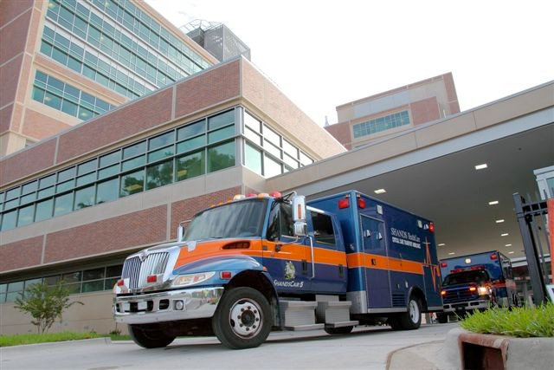

University of Florida College of Medicine Department of Emergency Medicine
Fourth-Year Emergency Medicine Clerkship Syllabus
WELCOME 3
MESSAGE FROM THE CHAIR 4
EMERGENCY MEDICINE CLERKSHIP ORGANIZATION & LOCATIONS 5
COMPETENCIES, GOALS & OBJECTIVES 6
POLICIES AND PROCEDURES 10
THE EMERGENCY MEDICINE CLERKSHIP EXPERIENCE 12
ROLES & RESPONSIBILITIES OF THE EMERGENCY MEDICINE CLERKSHIP 15
EMERGENCY MEDICINE RESOURCES 16
CLERKSHIP EVALAUTION FORM 16

Welcome

Welcome to the Department of Emergency Medicine.

Our goal is to provide you with the skill set to needed to address the undifferentiated emergency room and whatever comes through our doors. We do so by providing the best faculty and resident teaching you can receive. We also have an excellent experienced nursing team and support personnel. We are all dedicated to your education and we want you to leave this clerkship with the confidence and competence to be able to care for acutely ill patients.

We have a very diverse mix of patients that encompasses all key areas of emergency medicine. You will see a continuum of patient acuity and a broadest scope of patient presentations. You will see patients immediately as they present to the Emergency Department and follow them throughout their workup until discharge.

The emergency medicine clerkship consists of experiences in direct patient care of acutely ill patients, bedside teaching rounds, focused readings and weekly resident as well as dedicated student review sessions and patient simulation cases. You will also have ample opportunities to perform procedures, ultrasound examinations and aid in the management of critically ill medical and trauma patients. We provide every student with a safe and interactive experience ideally suited for learning. We provide excellent teaching and student-centered feedback to make this the best clerkship rotation for you.

We hope during this time you will display an eagerness to learn, to teach yourself and others. Again, welcome and we hope you enjoy this opportunity work more independently. Enjoy yourself and work hard. You and your future patients will benefit from this experience.

Regards,

Matthew Ryan, M.D., Ph.D.
Clerkship Director

Mike Marchick, M.D.
Assistant Clerkship Director

Courtney Cribbs
Clerkship Coordinator

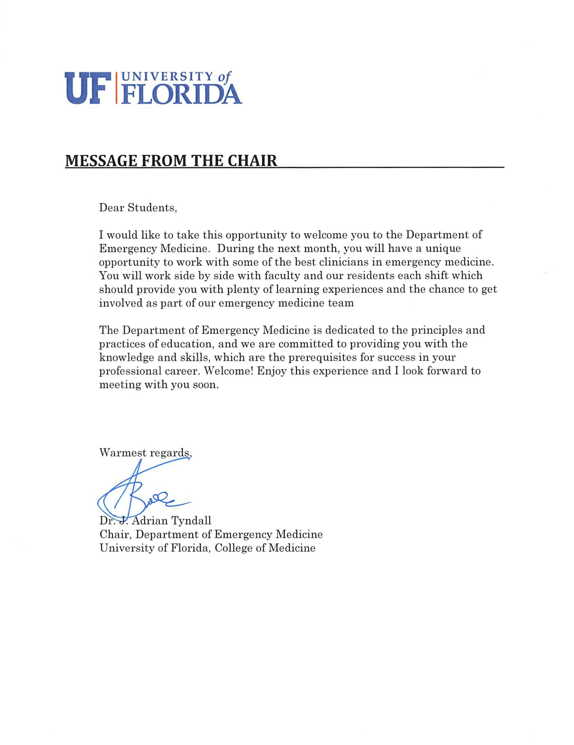

Emergency Medicine Clerkship Organization & Locations

Administration

Department Chair:
- Adrian Tyndall, M.D. (352) 265-5911 tyndall@ufl.edu

Emergency Medicine Medical Directors
Brandon Allen, MD (Adult ED) brandonrallen@ufl.edu
Jennifer Light, MD (Pediatric ED) light@ufl.edu

Clerkship Directors:
Matthew Ryan, M.D. Ph.D. | (352) 265-5911 | mfryan@ufl.edu
Michael Marchick, MD | (352) 265-5911 | marchick@ufl.edu
Meredith Thompson, MD | (352) 265-5911 | monin@ufl.edu

Emergency Medicine Clerkship Coordinator:
Courtney Cribbs (352) 265-5911 crlindsey@ufl.edu

Emergency Medicine Residency Leadership:

Lars Beattie, MS, MD | (352) 265-5911 | Program Director
Henry Young, MD | (352) 265-5911 | Associate Program Director
Giuliano De Portu, MD | (352) 265-5911 | Assistant Program Director
Nicholas Maldonado, MD | (352) 265-5911 | Assistant Program Director

UFHealth Gainesville Emergency Department Locations

Adult Emergency Department South Tower
1600 SW Archer Road, Gainesville, FL 32610 (800) 749-7424
(352) 733-0815

Pediatric Emergency Department North Tower
1600 SW Archer Road, Gainesville, FL 32608 352-265-KIDS

COMPETENCIES, GOALS & OBJECTIVES
The Department’s expectations of your performance are aligned with the College of Medicine’s competency-based curriculum. You will experience, be taught, and evaluated specifically on your performance of the following competencies, goals, and objectives:

Competencies

Professionalism (P)
  - Practice-based learning (PBL)
  - Patient care (PC)
  - Interpersonal and communication (IC)
  - Medical knowledge (MK)
  - System based practice (SBP)

Goals & Objectives

GOAL 1: Evaluate and manage patients in the Emergency Department.
Objectives:
- Independently obtain and record a patient’s history in a logical, organized, and thorough manner, taking into consideration the developmental stage of the patient. (PC)
- Refine physical examination skills by independently performing and recording a physical examination in a logical, organized, and thorough manner including advanced physical examination maneuvers. (PC)
- Understand and be able to communicate the reason for the patient’s presentation to the emergency department and learn admission criteria for common illnesses. (PC, IC, MK)
- Recognize patients requiring emergent attention by a supervising physician. (PC, IC)
- Recognize and stabilize patients with life-threatening conditions. (PC)
- Initiate patient orders, understand the rationale for each order, and be able to interpret each test ordered, including fluid management, CBC, coagulation studies, serum chemistries, urine chemistries, ECGs, telemetry, and common radiology studies. (PC, MK)
- Formulate a comprehensive problem list and differential diagnosis based on the history, physical examination, and laboratory data obtained. (MK)
- Develop skills needed for management and stabilization of life-threatening emergencies using evidenced-based practices such as ACLS, PALS, and ATLS. (PC, MK, PBL, SBP)
- Learn how to approach the management of an undifferentiated patient through their entire emergency department course to final disposition. (PC, MK, SBP)
- Generate thoughtful assessments and initiate a plan of evaluation and/or management and describe it to the team. (PC)
- List drugs of choice and the rationale for their use in common illnesses. (PC, MK)
- Identify contraindications, risks and benefits of therapeutic drug used in the emergency department and with regard to life-saving measures. (PC, MK)
- Modify the primary diagnosis and management plans based on diagnostic information. (PC, MK)
- Continuously reassess patients throughout their course in emergency department and notify the care team as to any changes in the patient or their care plan. (PC, IC, PBL)

- Demonstrate patient-centered approach to care. (PC, IC, P)
- Recognize variations in common laboratory findings and vital signs (heart rate, blood pressure, respiratory rate, and temperature as well as oxygen saturation). (MK)
- Summarize interval patient information and rationale for ongoing management. (PC)
- Identify patient discharge needs from the emergency department and include these in the discharge plan. (PC, IC)
- Manage time effectively in completing patient care tasks. (PC)
- Follow appropriate infection control measures while caring for patients. (PC)
- Identify relevant clinical information necessary for safe. (PC, IC)

GOAL 2: Work effectively as part of an inpatient team to care for patients and with increased independence in preparation for residency training.
Objectives:
  - Present a patient history, physical examination, laboratory data, assessment, and plan in a concise, organized manner. (PC)
  - Present a concise and well-organized follow-up presentation for each patient during their emergency department course with particular attention to the changes in patient condition and diagnostic and therapeutic plans. (PC)
  - Weighs risks, benefits, evidence, and costs when recommending diagnostic and therapeutic plans. (SBP)
  - Establish excellent rapport with patients as their primary caregiver (without misrepresentation of student status), including addressing the emotional and social needs of the patient and appropriate family members. (IC)
  - Effectively communicate with other members of the health care team including nurses, social workers, consultants, physical therapists, and ancillary staff. Consistently demonstrate respect, reliability, helpfulness and initiative modeling the highest degree of professional behavior. (IC, SBP)
  - Coordinate activities regarding patient disposition insuring that the patient and/or caregiver clearly understands the plan, how to take all discharge medications and their risks, any new safety concerns, follow up arrangements, and any other needs specific to the patient. This includes ensuring the patient understands the need to return to the emergency department if any new concerns arise. (PC, SBP)

GOAL 3: Initiate a management plan for the important medical problems and be able to evaluate and initiate management for important medical emergencies.
Objectives:
    - Describe the epidemiology, pathophysiology, and clinical findings of common conditions that require hospitalization. (MK)
    - Respond to patient emergencies and initiate evaluation and treatment for patient stabilization and be able to describe the epidemiology, pathophysiology, and clinical findings of these common conditions. (PC, MK)
    - Describe the impact of chronic illness and acute exacerbations of chronic disease on a patient’s clinical findings and management. (MK, PC)

    - Appropriately treat pain and describe the principles of pain assessment and management. (PC, MK)
    - Apply an evidenced-based approach to problems and questions that arise in the clinical setting. (PBL)
    - Recognize when consultation from another service is required and initiate it in a timely and respectful fashion to the consultant. (SBP, IC)
    - Recognize potential sources of medical errors and be able to differentiate between individual vs. system problem that can lead to adverse outcomes. (SBP)

GOAL 4: Increase and refine procedural skills.
Objectives:
- Routinely perform when needed with proficiency. (PC, MK)
- Become proficient in basic procedures such as IV insertion, lumbar puncture, arterial puncture, urinary catheterization, etc. as the opportunities arise. (PC)
- Participate in patient simulations to introduce airway management, intubation, emergent patient stabilization, basic first aid skills, central-line placement and other higher level procedural skills. (PC)
- Describe the indications, contraindications, risks and benefits of the following emergent procedures (PC, MK):
  - Airway management and intubation
  - Various techniques that can be used to stabilize an airway
  - Emergency vascular access Central-line placement
  - Chest-tube insertion
  - Inter-osseous placement
  - Wound repair and management
  - Management of acute musculoskeletal injuries
- Log procedures during the clerkship. (PC, MK, PBL)

Goal 5: Demonstrate interpersonal and written communication skills that result in effective information exchange and collaboration with patients, their families, and all members of the health care team.
- Communicate effectively with patients and families across a broad range of socioeconomic and cultural backgrounds. (IC)
- Describe the elements of informed consent. (IC, MK)
- Demonstrate relationship building skills in each clinical encounter and inter-professional exchange. (IC)
- Elicit and recognize the perspectives and needs of families and provide care for patients within their social and cultural context. (IC, PBL)
- Include the patient and family in the decision-making process to the extent they desire. (IC)
- Recognize when interpreter services are needed and demonstrate how to use these services effectively. (IC)

- Provide education and patient instructions to patients and families, using written or visual methods, taking into account disparate health literacy levels. (IC)

GOAL 6: Continue to develop and refine life-long learning skills and professional behavior.
Objectives:
- Recognize limits and deficits in knowledge, skills, and attitudes and initiate a plan to obtain help from faculty, colleagues, and other informational resources. (P)
- Read daily about issues that affect patient care. (PBL)
- Always places the needs of the patient first and acts as the patient’s advocate. (P)
- Demonstrate personal accountability to patients, colleagues and staff, in order to provide the best patient care. (P, PC)
- Demonstrate integrity, compassion, respect, altruism, and empathy when interacting with all members of the health care team, patients and their families. (P)
- Demonstrate culturally effective care by understanding the important role of culture in the care of each patient, recognizing how one’s own beliefs affect patient care, and eliciting the cultural factors that may influence the care of the patient. (P, PBL, PC)
- Maintain appropriate professional boundaries with patients, families, and staff. (P)
- Identify strengths, deficiencies, and limits in one’s knowledge and clinical skills through self-evaluation. (P, PBL)

Policies and Procedures
The University of Florida Honor Code:
“We, the members of the University of Florida community, pledge to hold ourselves and our peers to the highest standards of honesty and integrity.”

Communication
Email is the predominant source of communication regarding updates in the clerkship. It is expected for you to check your email daily. Email is also the primary means of communicating with us. Our department is committed to an excellent student experience and we believe good communication is the principle foundation to achieving this goal.

Reporting Problems
Problems with the residents, an attending or a general concern should be reported to Dr. Ryan or Dr. Marchick as soon as possible. The Emergency Medicine Clerkship should be a great experience and all concerns will be addressed appropriately. For further information regarding medical student mistreatment, please refer to the Office of Student Affairs Policy and Procedures Handbook http://osa.med.ufl.edu/policies/.

Attendance
Attendance is required for all Emergency Medicine Clerkship activities. This includes attendance for all of your scheduled shifts, conference and the four review sessions and the final exam. During clinical rotations, typical “holidays” are not taken unless specifically mentioned during the orientation (Christmas and Thanksgiving are exempt from this rule). If you have any unexpected or planned absences, you MUST notify Dr. Ryan or Dr. Marchick and the Clerkship Coordinator in the Department of Emergency Medicine. The official COM policy can be viewed at: http://medinfo.ufl.edu:8050/year1/secure/ufcom-policy-student-evalations.pdf.

In the event of an absence, you will be required to make up the time missed in order to ensure adequate clinical experience. This may require an extra shift. Failure to adhere to these policies and procedures will result in a lowered professionalism competency score. Missed days which cannot be completed before end of the clerkship date results in a grade of “Incomplete”. For further information regarding attendance policies at the University of Florida, College of Medicine, please refer to the Office of Student Affairs Policy and Procedures Handbook http://osa.med.ufl.edu/policies/.

Unplanned Absences
In the event of a single day, unexpected absence due to illness, you MUST notify the Clerkship Coordinator in the Department of Emergency Medicine preferably by email (kmoench@ufl.edu) but also by phone (352) 265-5911 as soon as physically possible. You must also make contact with both the Clerkship Director and or chief residents. Text pages, email, phone call, all forms of communication are acceptable. If you do not communicate with the

office regarding your absence and Dr. Ryan, Dr. Marchick or Ms. Martin cannot reach you, we will notify the office of Medical Education and Dr. Novak that we have been unable to contact you and a search for you will be initiated.

Planned Absences
Students must contact the clerkship director as far in advance as possible (these requests must be made at least 4 weeks prior to the beginning of the clerkship) to discuss and obtain the permission of the clerkship director to be absent from assigned responsibilities in the case of planned meetings or events such as weddings or family gatherings, or the observation of a personal religious holiday. For further information regarding absence policies at the University of Florida, College of Medicine, please refer to the Office of Student Affairs Policy and Procedures Handbook http://osa.med.ufl.edu/policies/.

Holidays

Students are allotted the following holidays: Thanksgiving, Summer Break and Winter Break. Thanksgiving is defined as beginning at 7pm Wednesday the day before Thanksgiving and ending at 5am the following Monday. Summer and Winter Break are determined by the UF COM Academic Calendar. The COM recognizes other holidays, both religious and secular, which are of importance to some individuals and groups. Students wishing to observe these holidays must inform the Clerkship Coordinator in the Department of Emergency Medicine before their clerkship begins. In the event of such a request, an alternate assignment or arrangement may be provided to the student to ensure adequate an clinical experience.

The Emergency Medicine Clerkship Experience
The Emergency Medicine Clerkship is a four-week experience that takes place in both the adult and pediatric emergency departments at UFHealth. During this rotation, you will be interacting directly with Emergency Medicine house staff and attending physicians. We hope clerkship will be a rewarding clinical experience.
Remember that no two physicians are identical. By observing the approach of various physicians, you will notice differences in evaluations and work-ups, thus different ways to approach problems. The goal in medical education and training is to learn from all of these experiences, integrate the knowledge and practices you learn toward the developing your own style in becoming a competent and confident practicing clinician.

Prerequisites
Medical Students must demonstrate appropriate clinical skills by successfully completing the 3rd year core clerkships (including IM, Surgery, OB/Gyn, Pediatrics). It is not necessary to complete an Emergency Medicine rotation prior to this course. Students participating in the Career Track rotation must have interest in pursuing residency training in Emergency Medicine.

Orientation
On the first day of the clerkship students should report to the Emergency Medicine Offices in the fifth floor of the 1329 building unless notified to meet elsewhere. You will be contacted by email regarding the specific date, time and location of orientation for confirmation. Orientation will include expectations and rules, a tour of both of the Emergency Departments at UFHealth Shands Hospital and assignment of clinical schedules.

Shift Schedule (13 shifts per rotation)
Your experience includes 13 clinical shifts; up to three will be in the pediatric emergency department. The shift schedule will be given to you on the day of orientation and posted on the departmental website (http://emergency.med.ufl.edu/). Each shift is eight hours. Please arrive 10 minutes early to prepare for sign- out and get ready for your shift. We recommend you bring food, your stethoscope, a pen and other resources needed at your discretion. The specific shifts start at either 7 AM, 3 PM or 11 PM. After sign out, you are done for the day.

Didactic Lectures
Like all residents, attendance at lectures is required. Conferences are held every Thursday morning starting at 7:30 am. Kassandra Moench will email you weekly conference locations, times, and topics.

Student Review Sessions
Review sessions are hands-on educational experiences which utilize patient simulations. The sessions are Thursdays after conference in the Harrell Medical Eduction Building 4th floor. Each 2 hour session is held from 1:00–3:00 pm. These are required and offer a safe environment to practice the management of critical ill patients, running codes, intubation and other procedures and to work as a team.

Wilderness Walk
The Wilderness Walk is held once per block at the Devil’s Millhopper Geological State Park located at 4732 Millhoppper Road, Gainesville, Florida, 32652. The Walk is an opportunity to practice medicine in an austere environment and to learn basic wilderness first-aid techniques. Check your schedule for the date. We meet at 1 PM in the parking lot of the Devil’s Millhopper Geological State Park. Come prepared for a two-hour hike in

the woods taking into consideration the weather and the time of year. Items to consider taking with you include an umbrella as needed, water, sunscreen, bug repellent and a sense of adventure.

Alachua County Fire and Rescue Ride Along
One emergency medical service (EMS) ride-along is scheduled. An EMS ride-along evaluation form is provided and should be returned at the end of the rotation. Please wear black or blue slacks, comfortable closed-toe shoes, and a polo shirt of any color other than gray. Long hair should be tied back. Minimal jewelry is recommended. No jeans, sneakers, t-shirts or flip-flops. Note, you are representing both UF and Alachua County Fire and Rescue (ACFR) during your ride along. This is an excellent opportunity to see how first responders work in the field. Please sign the Observation Release Form and Non-Disclosure Acknowledgement for ACFR. Also, fill out your ride along form that will be given to you during orientation.

Shift Evaluation Performance Criteria
You will receive feedback on cases you see and present. We use a daily shift summary as the feedback instrument. Approximately 30 minutes before the end of each shift, approach your shift’s attending or senior resident reminding them that you need an evaluation of your shift performance. The shift summary sheet has space to list the cases you have seen that day and an abridged version of the main competencies. Summative feedback will be based upon the shift summaries. The summative feedback form will often reflect the overall collection of shift summaries, but may reflect instances such as improvement or regression of performance over the clerkship.
.
Final Exam
- The Final exam is administered at the end of the rotation. Examinations cannot be taken prior to this time. The clerkship coordinator will e-mail the exam time to you. The standardized exam was developed by the National Board of Medical Examiners. You will have three to complete the exam. The exam will make up 25% of your final score. PA students do not take the NBME exam but student externs do. The clerkship coordinator will be at the start of the exam to collect your books, shift evaluations, procedure log and ACFR form. If you have special needs for the exam, let us know as soon as possible.
- A failing grade on the written examination will require a repeat examination. If the subsequent repeat exam is passed, a passing grade will be recorded, but failure a second time will result in a final failing grade requiring referral to the academic status committee.
- If you cannot be present for the exam for a valid reason, please discuss this with the clerkship coordinator or directors as soon as possible to make other arrangements within one week of the original exam date. Any delay beyond this time must be approved at the discretion of the clerkship directors. Failure to do so will result in a zero grade for the exam, and require a make-up exam. The make-up exam in this case would be treated as a repeat exam, so subsequent failure of this exam would result in a recorded failing grade for the clerkship.

Final Grade Composition
Your grade will primarily be based on your clinical performance as documented in your evaluations from faculty and staff over the four-week rotation. Clinical evaluations will encompass the College of Medicine’s competency-based performance evaluation and specific comments regarding the cases you managed during your rotation. You are expected to attend the review sessions, grand rounds, resident conferences, and any other department educational functions during the rotation. A listing of these activities will be provided at the orientation session and on the department website. Failure to attend required sessions without prior approval will result in points being deducted from your final score

Shift Evaluations + NBME Emergency Medicine final exam + attendance and participation review sessions, ride along, conference and The Wilderness Walk = Final Grade

For further information regarding grades, please refer to the Office of Student Affairs Policy and Procedures Handbook http://osa.med.ufl.edu/policies/.

Roles & Responsibilities of the Emergency Medicine Clerkship
- Take ownership of your patients. You should be always aware of your patient’s status. You must ensure that your patient’s needs (labs, x-rays, IV’s, fluids, etc) are met. You are an integral part of your patients’ care.
- Present your history and physical and management plan to either a senior resident or attending. If the resident or attending alters the management plan, understand the rationale for the revised plan. Remember not to overlook vital signs, mental status and overall appearance and health of your patient.
- Always follow universal precautions.
- You must have HIPPA training prior to beginning any shifts in the Emergency Department, and must observe patient confidentiality at all times. While the Emergency Department is often a difficult environment in which to maintain confidentiality, all efforts need to be made to maintain confidentiality. If an environment exists that makes either you or the patient uncomfortable sharing information, please solicit help in rectifying the problem. Get consent from patients before discussing any medical information in front of others (including visitors in the patient’s room).
- When leaving at the end of a shift, make certain that all of your patients are signed out to the next team and make sure the senior resident or attending is aware of the change. Never leave the department without signing out a patient to the oncoming team.
- At the beginning of each shift, please introduce yourself to your attending and upper-level resident and discuss their personal approaches regarding seeing patients. Some attendings and residents may give you more responsibility, whereas others may prefer more supervision and oversight.
- If a patient you are managing deteriorates or appears to be in distress, notify an upper-level resident or attending immediately. Even if you are unsure, please notify someone immediately.
- After you complete your history and physical exam, promptly present your patient and management plan to either the attending or an upper level resident. This is an ideal time to ask questions and obtain feedback on your management skills.
- Arrive early for the beginning of all shifts and conferences. This is part of your professionalism grade. Sign-out begins promptly at the beginning of each shift. Be sure to sign in for all conferences and review sessions.
- Professional working attire is required. Scrubs are acceptable and preferred. Lab coats are optional.
- Consultants should be addressing specific questions about a patient and should not be called to see patients that should be managed by the Emergency Department. You can allow the residents or attending to discuss the case with consultants but you are encouraged to speak with consultants as needed. Communication is an essential part of medicine and you should able to articulate a problem to a specialist by using proper terms and descriptions.

Student and Course Evaluations
- Course: All students are expected to log into StudyCore and complete a confidential survey regarding your emergency medicine clerkship experience. These evaluations are vital to the success of the clerkship by ensuring adequate levels of teaching. This feedback is also helpful in resident/faculty evaluations and award nominations. Please fill out evaluations on the Clerkship, Faculty, and the Residents on-line. We have implemented changes to our Clerkship based solely on student feedback. This is your opportunity to let us know what we did right and what we can do better: the feedback you provide is very important to the continued improvement of the clerkship. Please complete the on-line evaluations prior to the final exam. If possible, evaluate the overall clerkship, the director, and ca. 5 attendings and/or residents.

Emergency Medicine Resources

Recommended Overviews
  - Rosen's Emergency Medicine: Concepts and Clinical Practice by John Marx MD
  - Tintinalli's Emergency Medicine: A Comprehensive Study Guide, Seventh Edition by Judith Tintinalli,
J. Stapczynski, O. John Ma, David Cline, Rita Cydulka, Garth Meckler
  - Clinical Procedures in Emergency Medicine by Roberts and Hedges

Easy to Use Reference Texts
  - Tintinalli's Emergency Medicine: Just the Facts, Third Edition by David Cline and O. John Ma
  - The Atlas of Emergency Medicine, Third Edition by Kevin Knoop et al.
  - First Aid for the Emergency medicine Clerkship, Stead et al.

Condensed Reference Texts
  - Quick Hits in Emergency Medicine by Brandon Allen, Latha Ganti and Bobby Desai
  - Tarascon Emergency Department Quick Reference Guide by D. Brady Pregerson
  - Tarascon Adult Emergency Pocketbook by Steven G. Rothrock
  - Tarascon Pediatric Emergency Pocketbook by Steven G. Rothrock K

Internet Resources
  - PubMed – http://www.ncbi.nlm.nih.gov
  - EmCrit.org – blog but has some excellent commentary
  - Up-to-Date – always useful and indeed up to date on most topics.
  - http://guides.uflib.ufl.edu/content.php?pid=32869&sid=240882 – this site contains dozes of on-line references including easy to read EKG books and books and references dedicated to all areas of emergency medicine.

CLERKSHIP EVALUATION FORM
