Subject: _______________

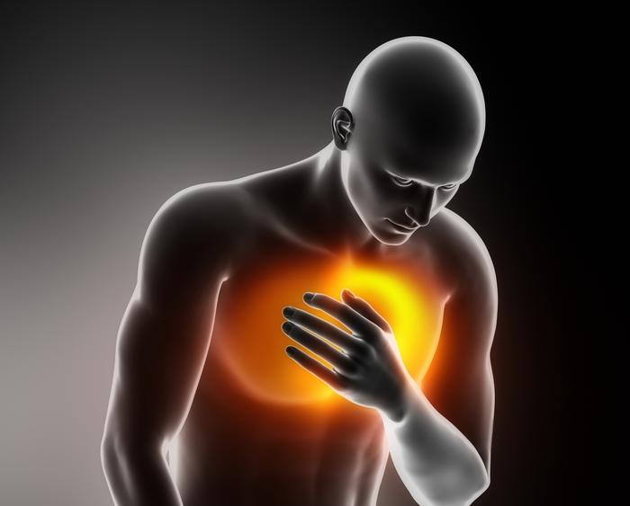

T0

T3

T2

**TIME RANGE: ____________________**

DRAW TIME: ______________

CENTRIFUGE TIME: ____________

FREEZER TIME: _____________

**TIME RANGE: ____________________**

DRAW TIME: ______________

CENTRIFUGE TIME: ____________

FREEZER TIME: _____________

**TIME RANGE: ____________________**

DRAW TIME: ______________

CENTRIFUGE TIME: ____________

FREEZER TIME: _____________

T1

DRAW TIME: ______________

CENTRIFUGE TIME: ____________

FREEZER TIME: _____________

***STOP CP TIME LOG***